System developed may be used across the glob which has different culture and people would like to see the system specific to their culture This is where concept of globalization come in to picture.

You design a system in such away that it automatically adopt to the local culture of the browser where is it used

Developed in such a way that it can be translated to multiple language and culture.

A software developed keeping globalization

Process of customizing the application to local culture using some input so that its available to the local client.

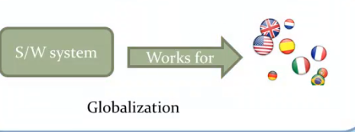

Process of localization and globalization:

Add all the code that will respond to the current thread culture for eg: date format, currency format number format etc.

Then add local resource or global resource

Design screen:

Design page >> Tools >> Generate local resources

This will add local resource file to new Application folder called App_LocalResources

Changes happen to the control

Meta:resourcekey=’resource label name’

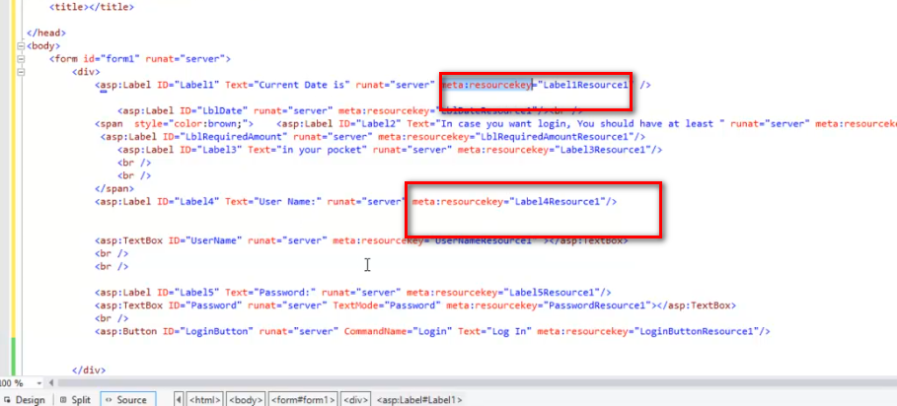

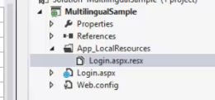

But this is specific to the page

But if we want to have single file which can share the translation we need to go for Global resources

App_Globalresources folder

Add resource translation inside it.

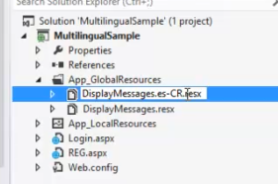

For multiple language use same copy of the file. But end the extension with 2 letter iso code at the end.

.es.CR.resx

.en.US.resx

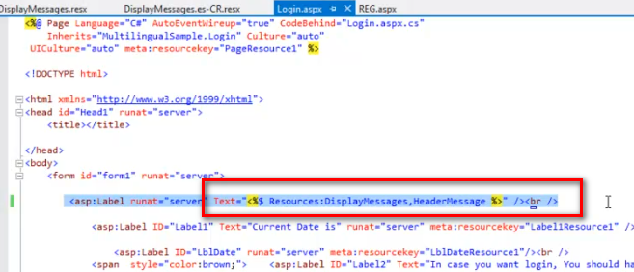

There are 2 property need to be configured on Web config or page level to set the thread culture.

UiCulture: when application loaded this will decide which resource file to be used for the translation

Culture: this will control the globalization of the culture specific methods

Levels of usability

Page level

Web config level

System local level (server)

Page level:

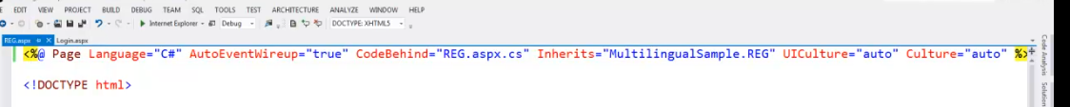

If we set it to auto it will take the browser language as culture

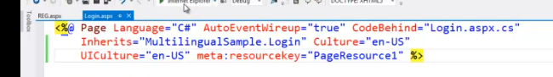

Takes English culture.

Web config level:

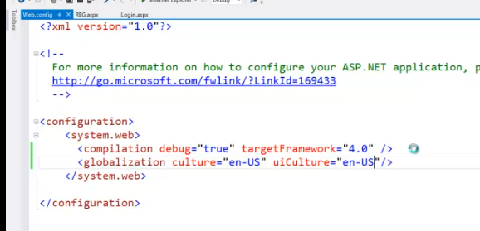

Changes done will be applicable thought the application

Setting by overriding the thread culture:

Define language selector in Design:

Override InitiaLizeCultureEvent

Override the thread culture

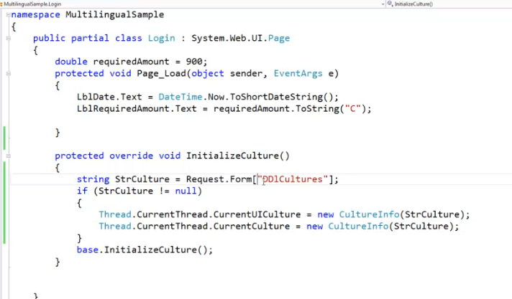

F the translations save on the Db level then we have to make a choice of making column which save the translations as Unicoded columns

Non Unicoded they takes 1 byte to save each character

Char

Varchar

Text

Unicoded character they take 2 bytes to save each character.

nChar

nVarchar

ntext